“Expert Cloud Consulting” -

SOP | Kubernetes Fundamentals
07.Jan.2025
version 1.0
─
Contributed by Tejal Kale
Approved by Akshay Shinde
Expert Cloud Consulting
Office #811, Gera Imperium Rise,
Hinjewadi Phase-II Rd, Pune, India – 411057

“Expert Cloud Consulting”

Kubernetes Fundamentals

1.0 Contents [ Heading3,14, Arial]

1.0 Contents [ Heading3,14, Arial] 1
2.0 General Information: [ Heading3,14, Arial] 2
2.1 Document Jira/ Github Ticket(s) [ Heading4,12, Arial] 2
2.2 Document Purpose 2
2.3 Document Revisions 2
2.4 Document References 2
3.0 Document Overview: 4
4.0 Steps / Procedure 5
4.1 : Setup the ubuntu server for .net core application 5
4.2: Choose an Amazon Machine Image (AMI) 5
4.3: Key-Pair Configuration 6
4.4: Network settings 6
4.3.1: VPC Configuration: 6
4.3.2: Security Group Configuration 7
4.4: Launch Instance 7
4.5: SSH Configuration 8
4.6: Install SSM Agent on Ubuntu Server 9
5.0 Annexure - I [ heading of content] 11



2.0 General Information:

2.1 Document Purpose
This document provides a comprehensive guide to deploying and managing a multi-tier application on Kubernetes using best practices, including autoscaling and secure configuration management.

2.3 Document Revisions
Date | Version | Contributor(s) | Approver(s) | Section(s) | Change(s)
11/02/2025 | 1.0 | Tejal Kale | Akshay Shinde/ | All Sections | New Document Created

3.0 Document Overview:
This guide includes step-by-step instructions for deploying a multi-tier application, configuring
Kubernetes components, and implementing autoscaling strategies.

4.0Architecture
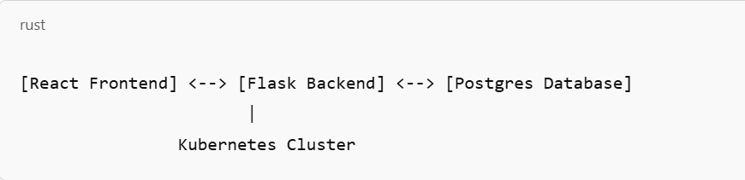

Prerequisites
- Installed Kind
- kubectl CLI
- Docker
- AWS Instance
- Access to DockerHub or private container registry

Install Kind
Download Kind binary:
curl -Lo ./kind https://kind.sigs.k8s.io/dl/v0.20.0/kind-linux-amd64

Make the binary executable:
chmod +x ./kind

Move it to a directory in your PATH:
sudo mv ./kind /usr/local/bin/kind

Verify Installation
Run the following command to confirm that Kind is installed:
kind version

For Ubuntu (Linux)
- Update system packages:
sudo apt update
sudo apt upgrade
- Install required dependencies:
sudo apt install ca-certificates curl gnupg lsb-release
- Add Docker's official GPG key:
sudo mkdir -p /etc/apt/keyrings
curl -fsSL https://download.docker.com/linux/ubuntu/gpg | sudo gpg --dearmor -o /etc/apt/keyrings/docker.gpg
- Set up Docker repository:
echo \
"deb [arch=$(dpkg --print-architecture) signed-by=/etc/apt/keyrings/docker.gpg] https://download.docker.com/linux/ubuntu \
$(lsb_release -cs) stable" | sudo tee /etc/apt/sources.list.d/docker.list > /dev/null
- Install Docker Engine:
sudo apt update
sudo apt install docker-ce docker-ce-cli containerd.io docker-buildx-plugin docker-compose-plugin
- Verify installation:
docker –version
- Run Docker without sudo (optional):
sudo usermod -aG docker
$USER newgrp docker

- Start Docker service
#sudo systemctl start docker
#sudo systemctl enable docker

Install kubectl
For Ubuntu/Debian
#curl -LO "https://dl.k8s.io/release/$(curl -L -s https://dl.k8s.io/release/stable.txt)/bin/linux/amd64/kubectl"
#sudo install -o root -g root -m 0755 kubectl /usr/local/bin/kubectl

- Verify installation
#kubectl version –client
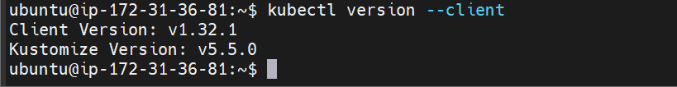

2. Development Environment Setup

2.1 Create React Application
- Create new React application
#npx create-react-app frontend
#cd frontend

- Install additional dependencies
#npm install axios react-router-dom

- Update package.json with correct versions

package.json:
```json
{
"name": "frontend",
"version": "0.1.0",
"private": true,
"dependencies": {
"axios": "^1.6.2",
"react": "^18.2.0",
"react-dom": "^18.2.0",
"react-router-dom": "^6.20.0",
"react-scripts": "5.0.1",
"web-vitals": "^2.1.4"
},
"scripts": {
"start": "react-scripts start",
"build": "react-scripts build",
"test": "react-scripts test",
"eject": "react-scripts eject"
}
}

2.2 Create Flask Backend
- Create backend directory
#mkdir backend
#cd backend

- Create virtual environment
#python3 -m venv venv

- Activate virtual environment
#source venv/bin/activate ( For Unix)

- Install required packages
#pip install flask flask-cors psycopg2-binary python-dotenv

- Create requirements.txt
#pip freeze > requirements.txt

- Create app.py:
python
from flask import Flask, jsonify
from flask_cors import CORS
import os
import psycopg2
from dotenv import load_dotenv

load_dotenv()

app = Flask(__name__)
CORS(app)

def get_db_connection():
conn = psycopg2.connect(
host=os.environ['DB_HOST'],
database=os.environ['DB_NAME'],
user=os.environ['DB_USER'],
password=os.environ['DB_PASSWORD']
)
return conn

@app.route('/api/data')
def get_data():
conn = get_db_connection()
cur = conn.cursor()
cur.execute('SELECT * FROM items;')
items = cur.fetchall()
cur.close()
conn.close()
return jsonify([{"id": item[0], "name": item[1]} for item in items])

if __name__ == '__main__':
app.run(host='0.0.0.0', port=5000)

3. Docker Setup & Containerization

3.1 Frontend Dockerfile
- Create Dockerfile in frontend directory:
FROM node:18-alpine as builder
WORKDIR /app
COPY package*.json ./
RUN npm install
COPY . .
RUN npm run build

FROM nginx:alpine
COPY --from=builder /app/build /usr/share/nginx/html
EXPOSE 80
CMD ["nginx", "-g", "daemon off;"]

3.2 Backend Dockerfile
- Create Dockerfile in backend directory:
FROM python:3.9-slim
WORKDIR /app
COPY requirements.txt .
RUN pip install -r requirements.txt
COPY . .
EXPOSE 5000
CMD ["python", "app.py"]

3.3 Build and Push Docker Images
- Login to Docker Hub
#docker login

- Build images
#docker build -t yourusername/frontend:latest ./frontend
#docker build -t yourusername/backend:latest ./backend

- Push images
#docker push yourusername/frontend:latest
#docker push yourusername/backend:latest

4. Kubernetes Setup with AWS EKS

4.1 Create EKS Cluster
- Create EKS cluster
#eksctl create cluster \
--name my-cluster \
--region us-east-1 \
--nodegroup-name standard-workers \
--node-type t3.medium \
--nodes 2 \
--nodes-min 1 \
--nodes-max 3 \
--with-oidc \
--ssh-access \
--ssh-public-key your-key-name \
--managed

- Configure kubectl
#aws eks update-kubeconfig --name my-cluster --region us-east-1

4.2 Create Kubernetes Configurations

- Create k8s directory structure:
#mkdir -p k8s/{config,database,backend,frontend}

- ConfigMap (k8s/config/configmap.yaml):
apiVersion: v1
kind: ConfigMap
metadata:
name: app-config
data:
DB_HOST: "postgres"
DB_NAME: "myapp"
DB_USER: "postgres"

- Secret (k8s/config/secret.yaml):
apiVersion: v1
kind: Secret
metadata:
name: app-secret
type: Opaque
data:
DB_PASSWORD: cG9zdGdyZXNwYXNz # base64 encoded

- Database Deployment (k8s/database/postgres-deployment.yaml):
apiVersion: apps/v1
kind: Deployment
metadata:
name: postgres
spec:
replicas: 1
selector:
matchLabels:
app: postgres
template:
metadata:
labels:
app: postgres
spec:
containers:
- name: postgres
image: postgres:13
env:
- name: POSTGRES_DB
valueFrom:
configMapKeyRef:
name: app-config
key: DB_NAME
- name: POSTGRES_PASSWORD
valueFrom:
secretKeyRef:
name: app-secret
key: DB_PASSWORD

- Backend Deployment (k8s/backend/backend-deployment.yaml):
apiVersion: apps/v1
kind: Deployment
metadata:
name: backend
spec:
replicas: 2
selector:
matchLabels:
app: backend
template:
metadata:
labels:
app: backend
spec:
containers:
- name: backend
image: yourusername/backend:latest
ports:
- containerPort: 5000
env:
- name: DB_HOST
valueFrom:
configMapKeyRef:
name: app-config
key: DB_HOST
- name: DB_PASSWORD
valueFrom:
secretKeyRef:
name: app-secret
key: DB_PASSWORD

- Frontend Service (k8s/frontend/frontend-service.yaml):
apiVersion: v1
kind: Service
metadata:
name: frontend
spec:
selector:
app: frontend
ports:
- port: 80
targetPort: 80
type: LoadBalancer

5. Deploy Application

5.1 Deploy to Kubernetes
- Apply configurations
#kubectl apply -f k8s/config/
#kubectl apply -f k8s/database/
#kubectl apply -f k8s/backend/
#kubectl apply -f k8s/frontend/

- Verify deployments
#kubectl get pods
#kubectl get services
#kubectl get deployments

5.2 Setup Autoscaling
- backend-hpa.yaml
apiVersion: autoscaling/v2
kind: HorizontalPodAutoscaler
metadata:
name: backend-hpa
spec:
scaleTargetRef:
apiVersion: apps/v1
kind: Deployment
name: backend
minReplicas: 2
maxReplicas: 5
metrics:
- type: Resource
resource:
name: cpu
target:
type: Utilization
averageUtilization: 70

Apply HPA:
kubectl apply -f k8s/backend/backend-hpa.yaml

6. Monitoring & Maintenance

6.1 Monitor Resources
- Monitor pods
#kubectl get pods -w

- Check logs
#kubectl logs -f <pod-name>

- Monitor resource usage
#kubectl top pods
#kubectl top nodes

- Check HPA status
#kubectl get hpa

6.2 Common Maintenance Commands
- Scale deployment
#kubectl scale deployment backend --replicas=3

- Update image
#kubectl set image deployment/backend backend=yourusername/backend:new-version

- Rolling restart
#kubectl rollout restart deployment backend

- View deployment status
#kubectl rollout status deployment backend

6.3 Cleanup
- Delete cluster
#eksctl delete cluster --name my-cluster --region us-east-1

- Delete individual resources
#kubectl delete -f k8s/

This completes the setup and deployment process. The application should now be running on EKS with autoscaling enabled. The frontend will be accessible via the LoadBalancer URL, which you can get using:
#kubectl get service frontend -o wide

7. Troubleshooting Guide

7.1 kubectl Configuration Issues

Updating kubectl Configuration for EKS
If you're experiencing issues connecting to your EKS cluster or getting authentication errors:

- Update kubeconfig for EKS cluster
#aws eks --region us-east-1 update-kubeconfig --name my-cluster

- Verify the current context
#kubectl config current-context

- List all available contexts
#kubectl config get-contexts

- Switch to a specific context if needed
#kubectl config use-context <context-name>

7.2 Common Issues and Solutions:

7.2.1. Authentication Errors
- Check AWS CLI configuration
#aws configure list

- Verify AWS credentials
#aws sts get-caller-identity

- Check if IAM user/role has proper EKS permissions
#aws eks describe-cluster --name my-cluster --region us-east-1

7.2.2. Expired Tokens
- Clear kubectl cache
#rm -rf ~/.kube/cache

- Update AWS credentials
#aws configure

- Update kubeconfig
#aws eks update-kubeconfig --name my-cluster --region us-east-1

7.2.3. Multiple Clusters Configuration
- View full kubeconfig
#kubectl config view

- Delete specific cluster configuration if needed
#kubectl config delete-cluster <cluster-name>
#kubectl config delete-context <context-name>
#kubectl config delete-user <user-name>

- Set default namespace for current context
#kubectl config set-context --current --namespace=default

7.2.4 Cluster Connection Issues

- Test cluster connectivity
#kubectl cluster-info

- Describe cluster status
#aws eks describe-cluster --name my-cluster --region us-east-1

- Check node status
#kubectl get nodes
#kubectl describe node <node-name>

7.3 Pod and Service Issues

1. Pod Troubleshooting

- Get pod details with wide output
#kubectl get pods -o wide

- Check pod logs
#kubectl logs <pod-name> --previous # Get previous container logs if pod crashed
#kubectl logs <pod-name> -c <container-name> # For multi-container pods

- Execute commands in pod
#kubectl exec -it <pod-name> -- /bin/bash

2. Service Connectivity
- Check service endpoints
#kubectl get endpoints

- Test service DNS resolution
#kubectl run -it --rm --restart=Never busybox --image=busybox:1.28 -- nslookup <service-name>

- Port-forward to test service locally
#kubectl port-forward service/<service-name> 8080:80

7.4 Common Error Scenarios and Solutions

1. magePullBackOff Error
- Check pod description for image pull errors
#kubectl describe pod <pod-name>

- Verify Docker credentials
#kubectl create secret docker-registry regcred \
--docker-server=<your-registry-server> \
--docker-username=<your-name> \
--docker-password=<your-pword> \
--docker-email=<your-email>

2. CrashLoopBackOff Error
- Get detailed pod information
#kubectl describe pod <pod-name>

- Check container logs
#kubectl logs <pod-name> --previous

- Check events in namespace
#kubectl get events --sort-by=.metadata.creationTimestamp

7.5 Resource Constraints

- Check resource usage
#kubectl top pods
# kubectl

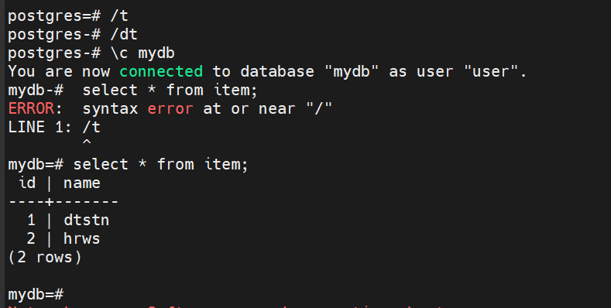

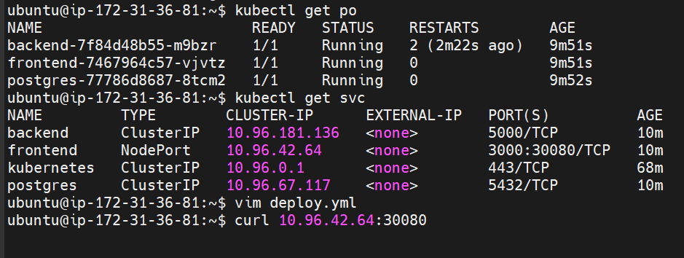

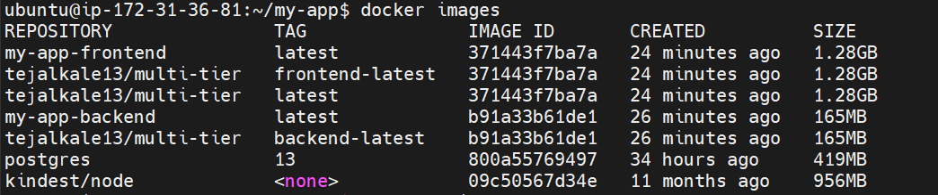

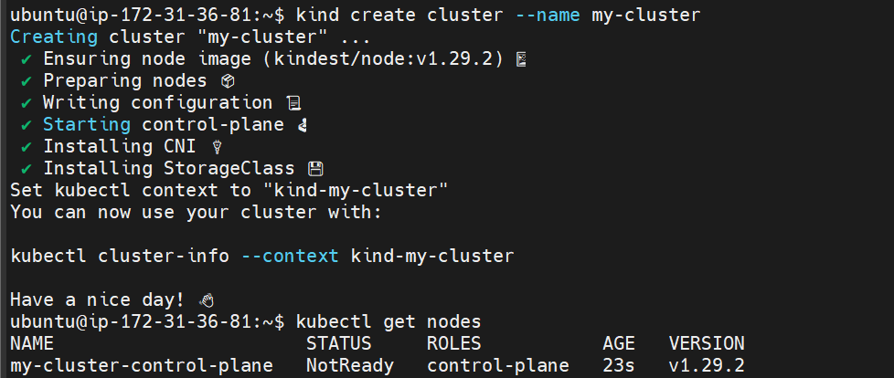

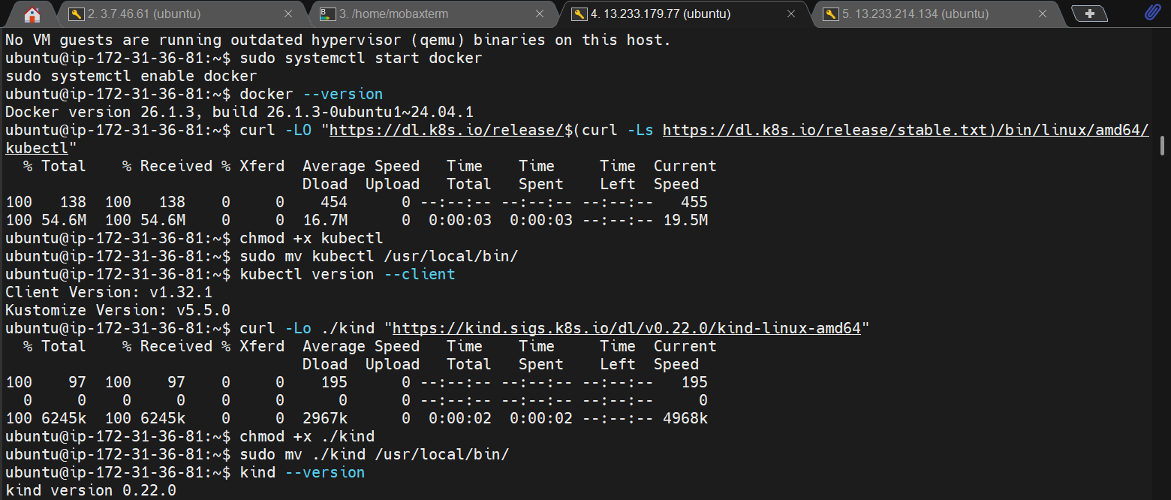

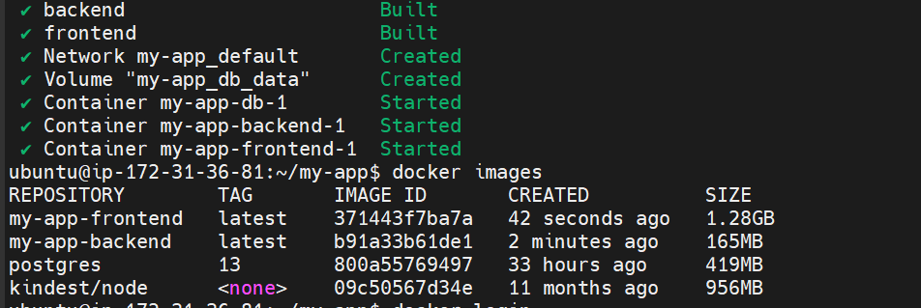

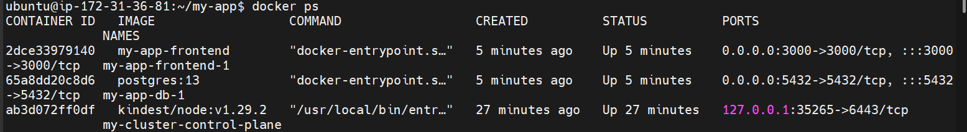

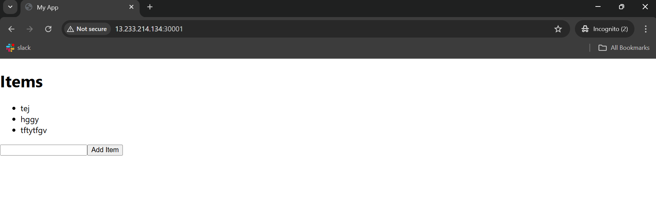
Frontend dockerfile
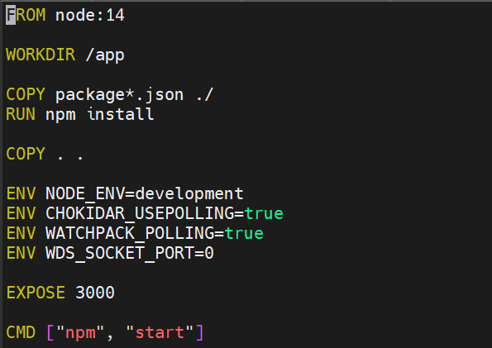
backend dockerfile

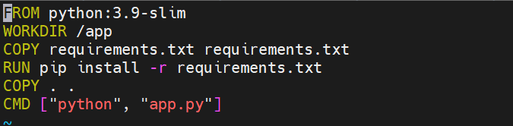

Docker-compose.yml
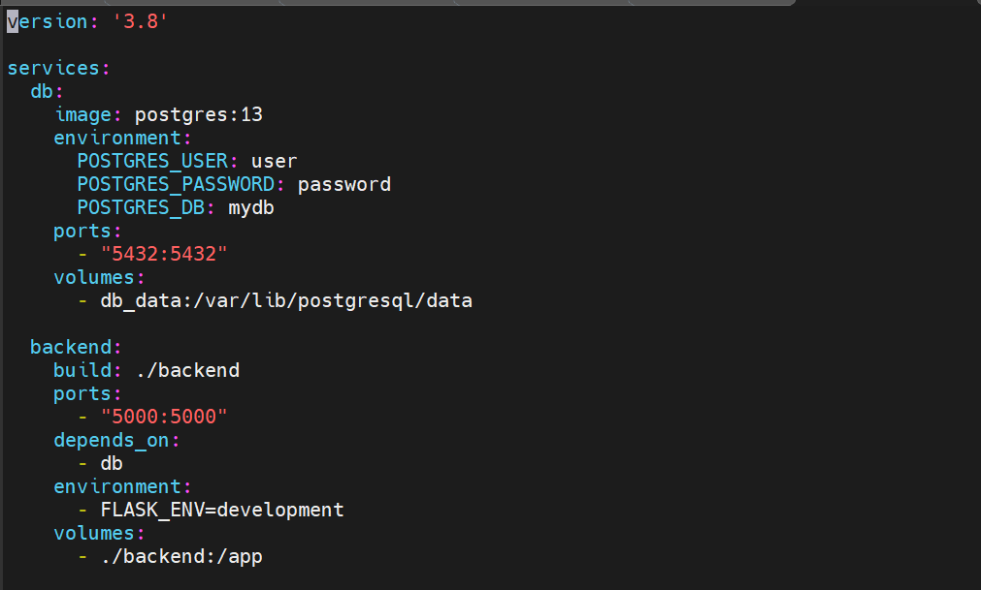
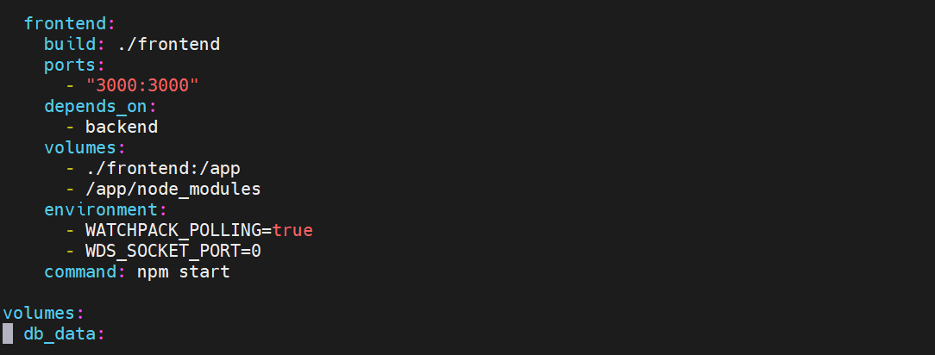

K8S CLUSTER FILE
